

Guiding the next generation

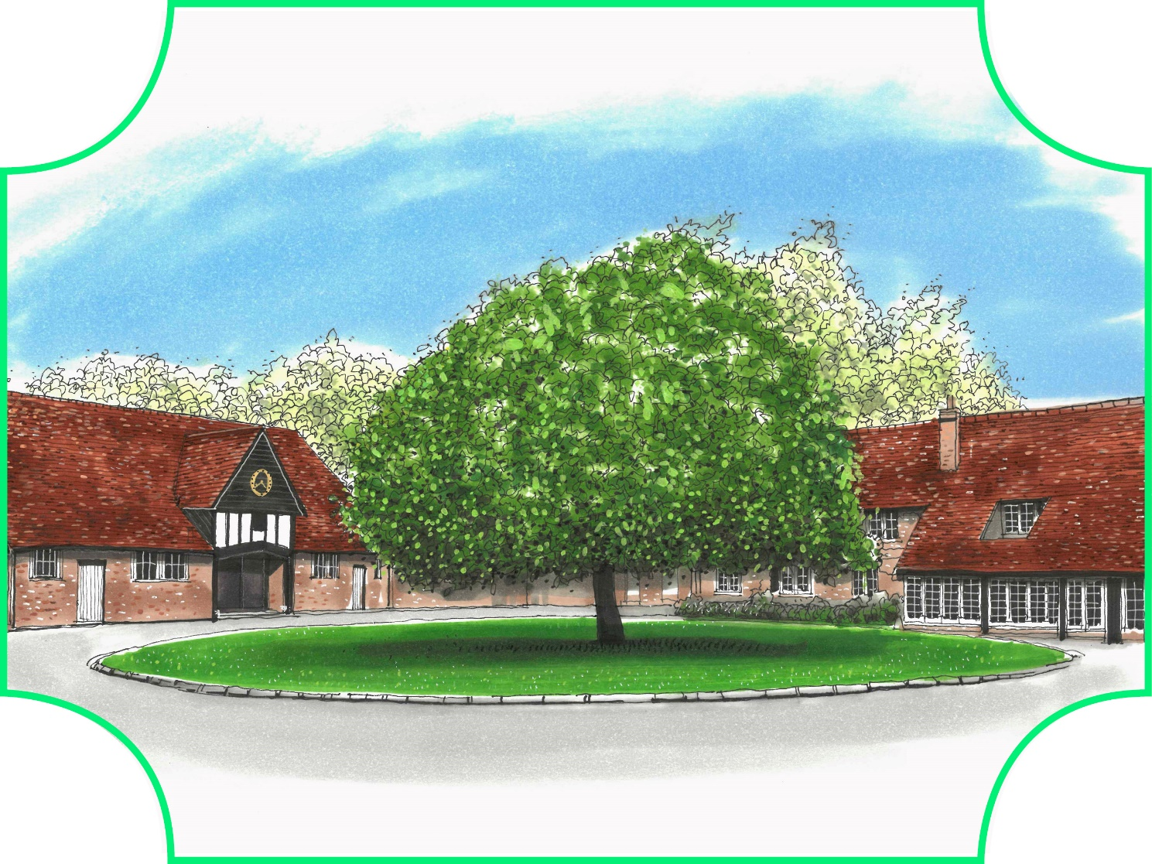

NURSERY/ EARLY YEARS TEACHER

Permanent - Full Time

For September 2026

INTRODUCTION

The Beacon was founded in 1933 by its first Headmaster, Stanley Fieldhouse, opening with just 5 pupils.

Today, The Beacon has over 450 pupils from Nursery to Year 8 and is set in 18 acres within the Chilterns countryside, located in Amersham.

Whilst The Beacon currently educates boys, the school is to become co-educational in September 2027. The first girls will join the Nursery in September 2026 with a further intake at the normal entry points of Reception, Year 3 and Year 7 in September 2027.

GUIDING THE NEXT GENERATION

The Beacon prides itself on academic excellence, abundant opportunities and our ability to identify an individual’s potential; preparing them for what’s now, what’s next, and wherever life may take them.
ACHIEVE ACADEMICALLY. PROSPER PERSONALLY.

From the first steps to the last exam, our team of inspiring teachers and staff deliver best-in-class education in an enriching and enlightening environment.
THE BEACON VALUES
Our values are embedded into Beacon Life.
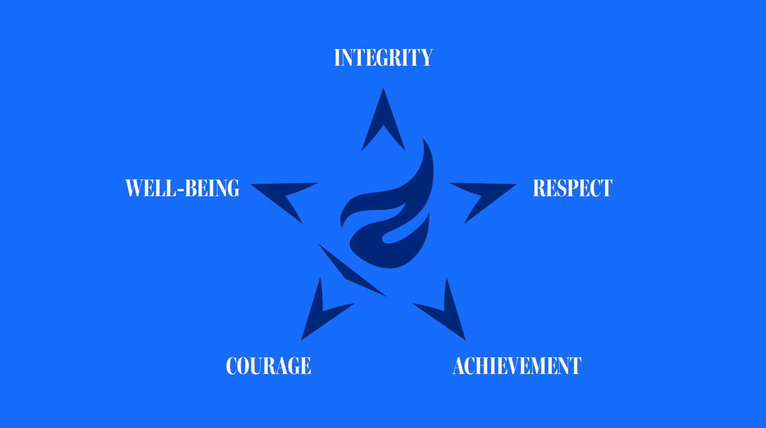


WELCOME FROM THE HEADMASTER

Dear Applicant,

Thank you for your interest in the position of Nursery/ Early Years Teacher at The Beacon.

We are seeking to appoint an exceptional and inspirational teacher to join our Pre-Prep team from September 2026. This role is full time, and we are keen to hear from suitable candidates wishing to work in our Early Years team, particularly in Nursery.

The Beacon is a large prep school for pupils aged between 3 and 13, with superb facilities and resources that support a forward-looking educational environment. The school is accessible by Chiltern Railways and Met Line, located close to Amersham.

To give you a flavour of life at The Beacon, please look at our website beaconschool.co.uk. Here, you will find our Safeguarding and Child Protection Policy too.

The Beacon is an exceptional school, and we seek exceptional people. I look forward to hearing from you.



Nick Baker
Headmaster

IMPORTANT NOTE:
- The school is committed to safeguarding and promoting the welfare of children. Safeguarding checks will be undertaken in accordance with School policy
- The safeguarding responsibilities of the post can be found in the job description and person specification in this recruitment pack
- The post is exempt from the Rehabilitation of Offenders Act 1974.

JOB SPECIFICATION

Job Title: Teacher (Nursery/ Early Years)

Hours: Full-time (Monday – Friday) where Normal School Hours during term time require attendance from 08:00 with allocation of after school duties etc.

MAIN DUTIES & RESPONSIBILITIES:

Academic

- To act as Teacher and to deliver lessons as timetabled per School requirements from year to year
- Together with the Head of Early Years, to prepare schemes of work
- To prepare Medium Term Plans
- To prepare and deliver lessons in line with the agreed curriculum and schemes of work
- To mark and assess pupils’ work and progress in line with the school and departmental policies and to record assessments in a clear and informative manner
- To report progress to parents at parents’ meetings and in written reports
- To ensure that the pupils’ work is presented and maintained in an organised, appropriate and accessible format
- To work closely in a team with other teachers and assistants, the Heads of Department, the Assistant Heads, and all members of the School Leadership Team
- To liaise with the staff in the Learning Support Centre to ensure that the needs of all pupils with SEN are met
- To maintain records and notes on academic issues in the electronic profiling system
- To encourage and stimulate the pupils to achieve excellence in all their endeavours and to expect high standards
- To provide a comfortable, stimulating and well-organised classroom environment, with a high standard of display work on notice boards

Other Responsibilities

- To attend INSET and other relevant training as required
- To attend staff meetings, Open Day/Mornings, Speech Day, Parents’ Evenings, and curriculum meetings
- To participate in Additional Duties which may include before/after school duties, break-time and lunchtime duties on a rota basis
- To assist with the organisation and running of trips and events as required
- To play a full part in the life of the school community, to support our distinctive mission and ethos and to encourage all our staff and pupils to follow this example

Flexibility: You may be required to undertake such other reasonable duties from time to time as the School may reasonably require.

SAFEGUARDING

Promoting and safeguarding the welfare of children and young persons for who you are responsible and with whom you come into contact; following the school’s safeguarding policy at all times and using the internal systems/contacting the DSL for monitoring safeguarding, wellbeing and pastoral issues.

Please Note:
- The role will bring you into contact with children at a high level of responsibility for children.
- The role constitutes regulated activity with children.
- In the role, you may also be required to undertake such other duties as the Head reasonably requires from time to time.



PERSON SPECIFICATION

 | Essential | Desirable
Qualifications | - Educated to degree level  - Suitable teacher/EYFS qualification, eg QTS
Experience | - Outstanding classroom practitioner  - Experience of working with primary school age group and successful teaching at EYFS | (Note: it is not essential to have worked in the independent sector)
Skills | - Excellent teaching abilities  - Highly organised  - Strong pastoral skills
Knowledge | - Relevant Early years and/ KS1 curriculum  - Up to date safeguarding training | Specialist subject or keen interest in a particular subject  Knowledge of ISAMS system
Other | - Able to quickly settle in to new environments  - Enthusiastic about learning and teaching  - Commitment to maintaining the highest standards in classroom delivery  - Friendly and approachable  - Ability to remain calm and professional in all situations  - Self-motivated and versatile  - Excellent role model  - Desire to contribute to school life beyond immediate classroom  - Highly professional with positive outlook  - Team player

THE PROCESS

The school is committed to safeguarding and promoting the welfare of children.

All applicants must be prepared to undergo appropriate child protection screening, including checks with past employers and the Disclosure and Barring Service. The Beacon is an equal opportunities employer. References will be required and any relevant issues arising from such will be taken up at interview or a suitable point during the process.

Candidates who have a disability or any other special requirements should let the school know if there are any reasonable adjustments they would like the school to make as part of this recruitment process.

There is a requirement to complete the school’s Application Form. Please download from TES/the school’s website and send a copy of your completed Application Form and covering letter by e-mail to: recruitment@beaconschool.co.uk

Closing date for receipt of applications is Friday 27 February 2026. Interview date to be confirmed.

We would encourage you to submit your application early as we reserve the right to close vacancies earlier than the deadline – if, for example, we receive a number of applications of interest early on.


Please note: CVs cannot be accepted. Whilst an interview is to be used as the primary feature of the selection process, if invited for interview you will be advised as to whether any additional selection methods will be required to supplement the interview. This may include a lesson, presentation and/or other task. Whatever methods are chosen, the panel will use these to assess the merits of each candidate against the job and person specification.

CONTACTS

Address: The Beacon, 15 Amersham Road, Chesham Bois, Amersham, Bucks, HP6 5PF

Telephone: The HR team at The Beacon 01494 433654

Email: recruitment@beaconschool.co.uk

Website: beaconschool.co.uk




