Senior Marketing & Communications Assistant
Fixed Term Contract
August 2021

Contents
Welcome 3
Aims and Ethos 4
Job Description 5
How to Apply 7

Address: The Beacon
Amersham Road
Chesham Bois
Amersham
Bucks
HP6 5PF

Telephone: 01494 736165
Email: recruitment@beaconschool.co.uk
Website: www.beaconschool.co.uk

The School is committed to safeguarding and promoting the welfare of children. Applicants must be prepared to undergo appropriate child protection screening, including checks with past employers and the Disclosure and Barring Service.
The Beacon is an equal opportunities employer.
Registered in England No. 01067862. Registered Charity No. 309911.
From Will Phelps Headmaster
Dear Applicant,

Thank you for your interest in the position of Senior Marketing and Communications Assistant at The Beacon.

This is a key role providing professional and effective support to the Marketing department. The successful applicant will possess excellent communication skills and a fine eye for detail. Working closely with our Marketing Manager, you will have marketing communications, creative or other relevant experience.

The role is being offered on a part-time 5 days a week, fixed term contract basis to July 2022, Term Time only, and we would like the successful applicant to start work in September/October this year.

The Beacon is a large prep school for boys aged between 3 and 13, with superb facilities and resources that support a forward-looking educational environment. Our school is set on an 18-acre site near Amersham, Buckinghamshire, some 30 minutes from London by train.

To give you a flavour of life at The Beacon, please take a look around our website www.beaconschool.co.uk. You will find our Safeguarding and Child Protection Policy on the Vacancies page and other useful policies on the website too.

The Beacon is a remarkable school, and we seek remarkable people. I look forward to hearing from you.
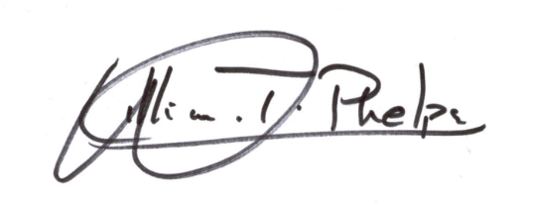

Will Phelps
Headmaster

Professional Standards

The Following is our ‘Circle of Success’. It is this which makes The Beacon a special place to be educated and work at. All our staff live and breathe by the professional principles below. If these resonate with you, you would definitely enjoy working at our School.
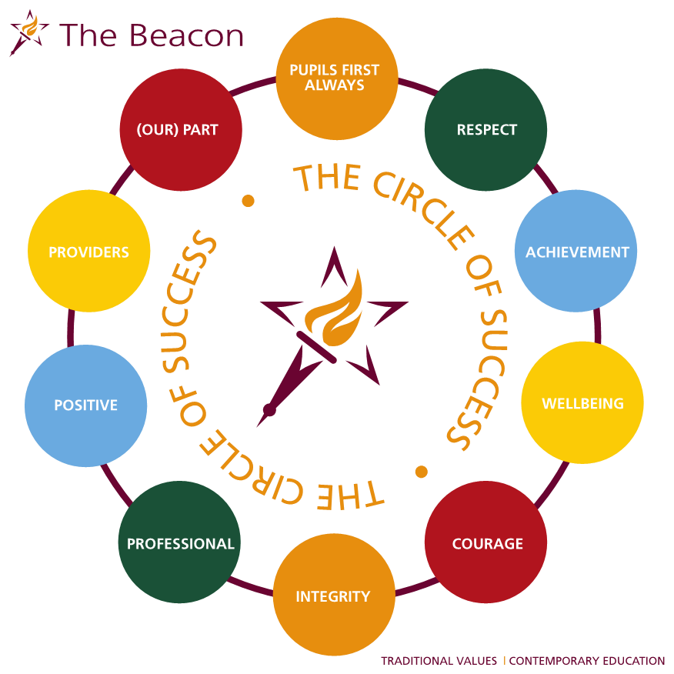

JOB DESCRIPTION
Senior Marketing and Communications Assistant

The School is committed to safeguarding and promoting the welfare of children and young people and expects all staff and volunteers to share this commitment. The following duties will be deemed to be included in the duties which you may be required to perform:
- child protection, discipline, health and safety
- promoting and safeguarding the welfare of children and young persons for whom you are responsible and with whom you come into contact.
You may be required to undertake such other reasonable duties from time to time as the School may reasonably require.

Overview

To play an active part in our marketing team assisting with both online and offline marketing and general communications duties, reporting to the Marketing Manager. The role will include creating, delivering and updating engaging content for our school, including but not limited to:
- Advertising
- Digital marketing
- Social media
- External marketing materials and prospectus
- Media and press
- Website
- Events posters and flyers
- Surveys
- Photo & Video library
- Parental Comms

Main Duties & Responsibilities
- To explore and develop proposals of new advertising and marketing initiatives
- To help implement marketing campaigns
- To design and edit marketing communications materials
- To generate ideas for weekly website news stories, social media content plan and weekly newsletter content
- To build press relations and develop copy content of press releases
- To copywrite and assist with proofing and editing of marketing and other school communications (including parental communications)
- To help ensure school-wide branding compliance
- To support in campaign analysis and evaluation
- To assist in the photography and filming of school activities, broadcasts and events
- To assist in the planning, co-ordination and delivery of school events, including Open Days, Messy Play Mornings, Speech Day, talks, and exhibitions
- To assist with market research, school surveys and analysis
To undertake such other reasonable duties from time to time as the School may reasonably require.

Skills (E = essential; D = desirable)

- Previous experience of working in marketing or related field (D)
- Marketing related or other relevant creative degree (D)
- Excellent writing skills (E)
- Creative flair (E)
- Strong understanding of digital advertising and social media (E)
- Interest in photography / video (E)
- Good communication skills (E)
- Responsible and organised with meticulous attention to detail (E)
- Able to work both independently and as part of a team (E)
- Motivated, kind, confident and hard-working (E)
- Excited by the prospect of promoting one of the country’s largest and most successful prep schools (E)
- Knowledge of graphic design – InDesign, Illustrator and/or Adobe Photoshop (D)
- Knowledge of video editing programmes (D)
- Thorough knowledge of Word, Outlook, Excel etc as well confident about learning new IT packages (E)

Terms
Hours: Part-time, 5 days a week (25 hours per week), Term Time only. 10am-3pm daily Monday-Friday

Duration: Fixed Term contract to end of Summer 21/22 Term (July 2022)

Start: September/October 2021 - subject to satisfactory vetting and DBS, etc.

The Process

The school is committed to safeguarding and promoting the welfare of children.
All applicants must be prepared to undergo appropriate child protection screening, including checks with past employers and the Disclosure and Barring Service. The Beacon is an equal opportunities employer. References will be required and any relevant issues arising from such will be taken up at interview or a suitable point during the process.

Candidates who have a disability or any other special requirements should let the school know if there are any reasonable adjustments they would like the school to make as part of this recruitment process.

There is a requirement to complete the school’s Application Form which can be completed online. Alternatively, please send a copy of your completed Application Form and covering letter:

- by e-mail to: recruitment@beaconschool.co.uk

- or by post to: Mr Will Phelps, Headmaster, The Beacon School, Amersham Road, Chesham Bois, Amersham, Bucks HP6 5PF

The closing date for receipt of applications is 16:00 on Monday 23 August and interviews will be held the following weeks.

(Please note that whilst an interview is to be used as the primary feature of the selection process, if invited for interview you will be advised as to whether any additional selection methods will be required to supplement the interview. This may include a presentation and/or other task. Whatever methods are chosen, the panel will use these to assess the merits of each candidate against the job and person specification).

